**BUILD AN EVENT MANAGEMENT SYSTEM USING SALESFORCE**

1. **INTRODUCTION:**

**1.1 Overview:**

Event management is the process of creating and maintaining an event. This process spans from the very beginning of planning all the way to post-event strategizing.At the start, an event manager makes planning decisions, such as the time, location, and theme of their event. During an event, event managers oversee the event live and make sure things run smoothly. After an event, event managers are tasked with reviewing event data, submitting KPI and ROI findings, and staying on the ball for any post event offering.

All different branches of planning go into event management, including various types of sourcing, designing, regulation checks, and on-site management. In event management, you could be in the process of creating a conference, a product launch, an internal sales kick-off, or even a wedding. Really, any event that requires considerable planning and execution is event management.

Event management goes by [many different names.](https://www.cvent.com/en/blog/events/different-names-for-event-planners) Some event planners are called administrative assistants, some are called event coordinators, and others are called event technologists. What do all of these titles have in common? The individuals have some hand in planning an event. Whether the events are internal or external, large or small, in-person or virtual, they all have to be planned.

In today's new environment, we have had to learn how to manage not only our in-person events but our virtual programs as well. Virtual event management requires the same steps as managing your in-person event, but with the added challenge of making sure that your content is twice as captivating. While in-person events have the added in bonus of travel, networking, and free food, a virtual event largely relies on its content to keep attendees engaged.

**1.2 Purpose**

Event management is the process of creating and maintaining an event. This process pans from the very beginning of planning all the way to post-event strategizing. At the start, an event manager makes planning decisions, such as the time, location, and theme of their event.

2.PROBLEM DEFINITION & DESIGN THINKING

2.1 Empathy Map:

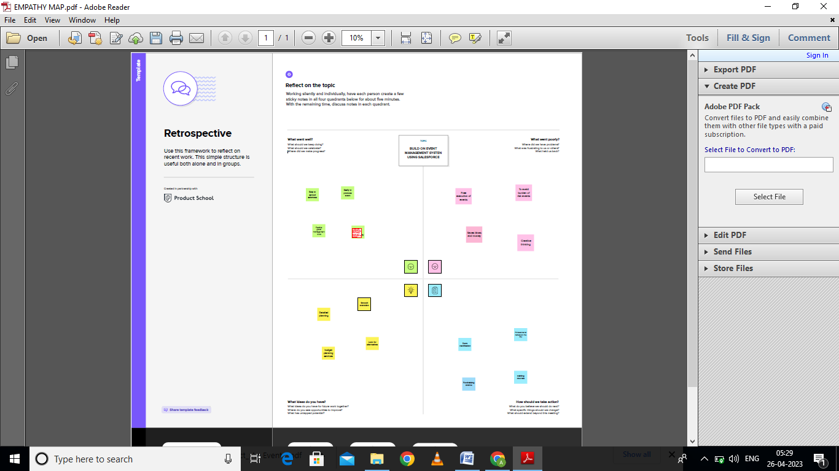

2.2 Ideation & Brainstorming Map:

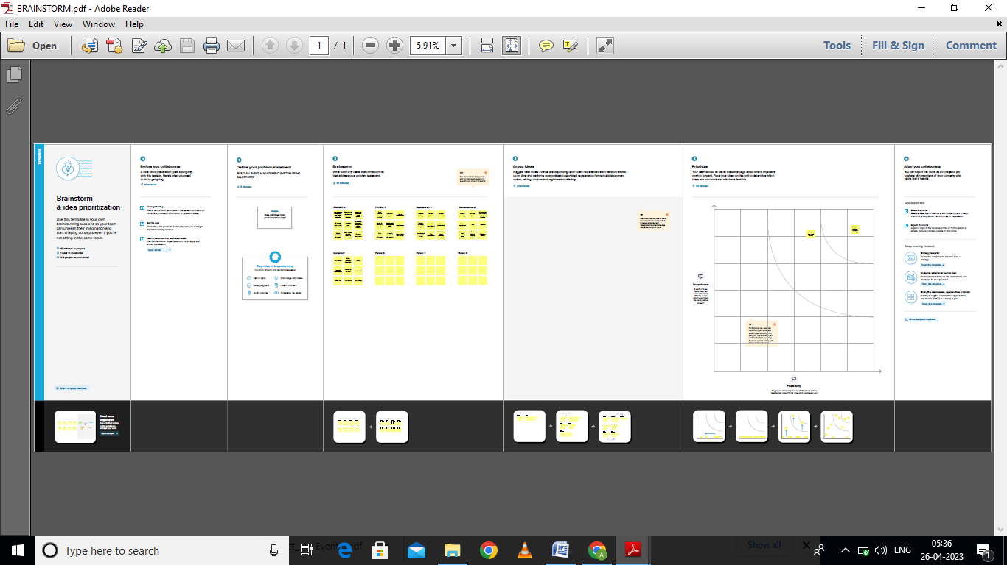

3.RESULT:

|  |  |  |
| --- | --- | --- |
| Object name | Field in the object | |
| Object 1: Event | Field Label | Data Type |
| Event name | Text |
| Start data | Data |
| Object 2:Attendee | Field Label | Data type |
| Attendee name | Text |
| Email | Email |
| Id | Auto number |
| Phone | phone |
| Attendee | Auto number |
| Object 3: Speaker | Field Label | Data Type |
| Speaker name | Text |
| Bio | Text area |
| Event | Lookup |
| Object 4: Vendor | Field Label | Data Type |
| Vendor name | Text |
| Phone | Phone |
| Service provider | Text |
| Event | Lookup |
| Email | Email |

3.2 Activity & Screenshot

Milestone 1-Salesforce

Activity: Creating a salesforce developer org:

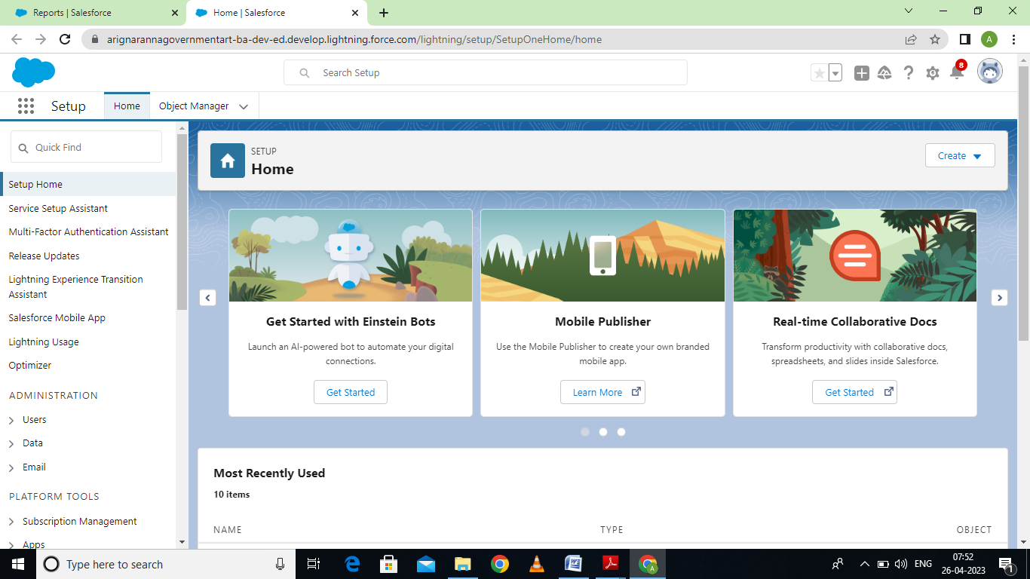

Milestone 2- object

Activity 1: creation of object for event management

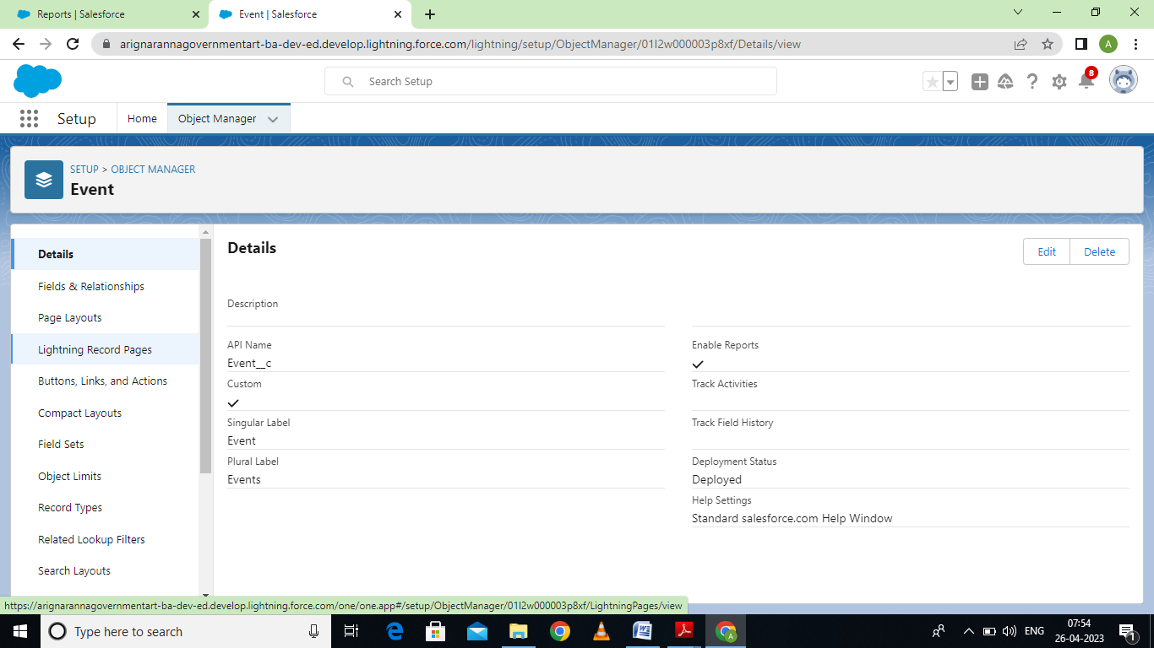

Activity 2:

Creation of Attendee object:

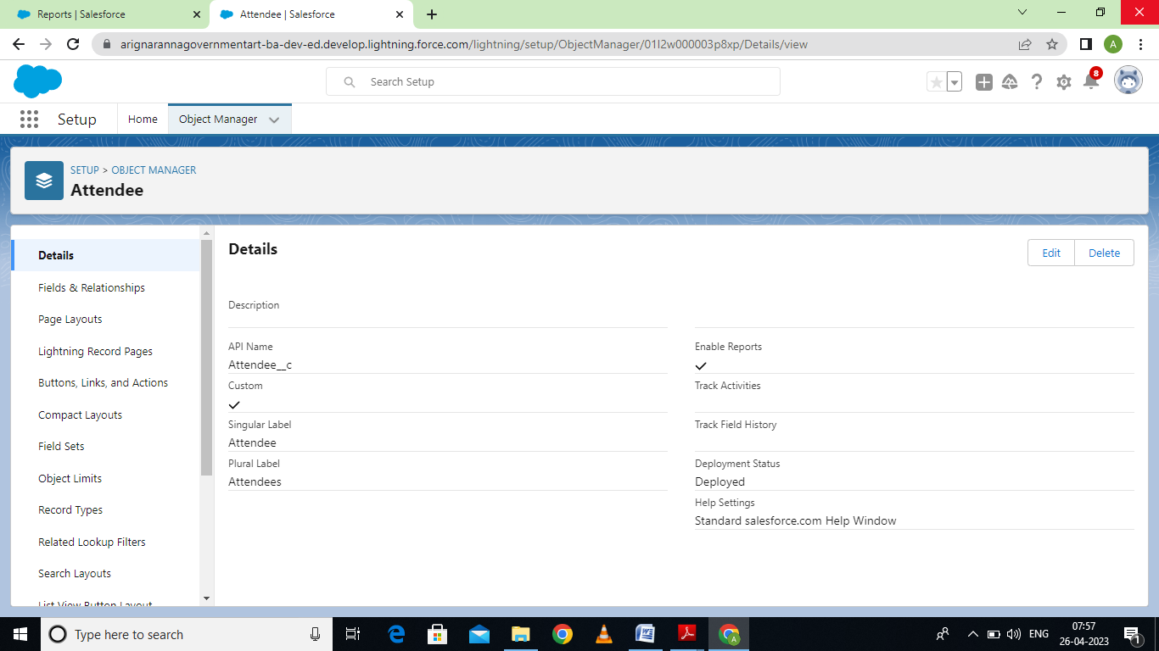

Activity 3:

Creation of speaker object:

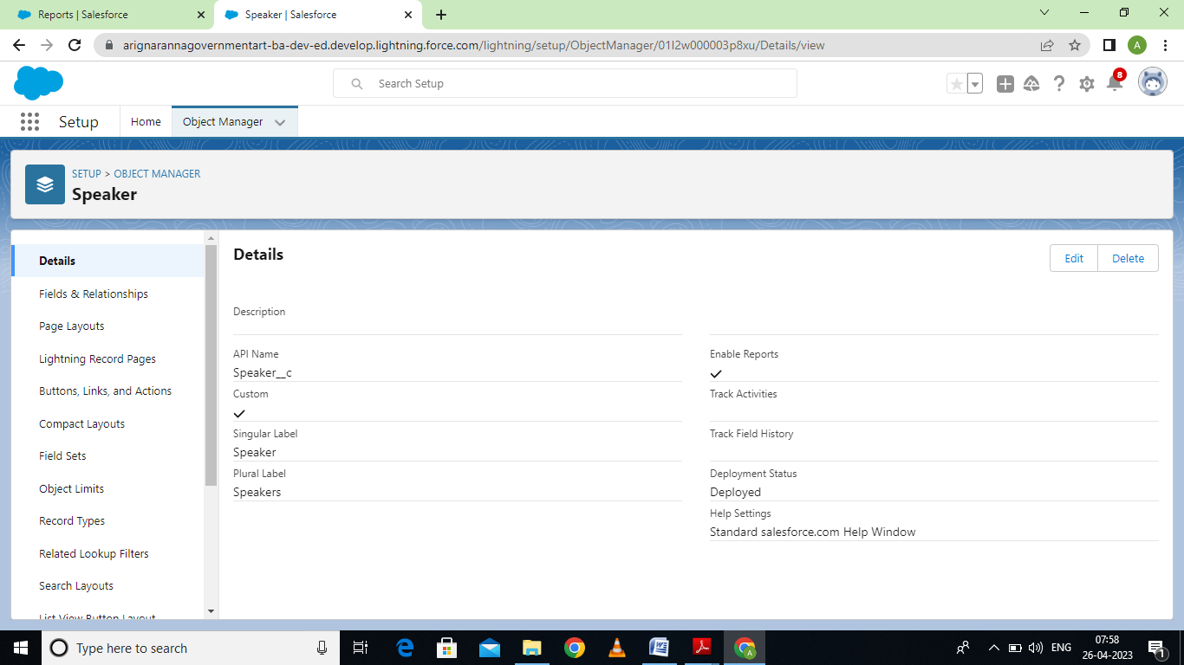

Activity 4: Creation of vendor object:

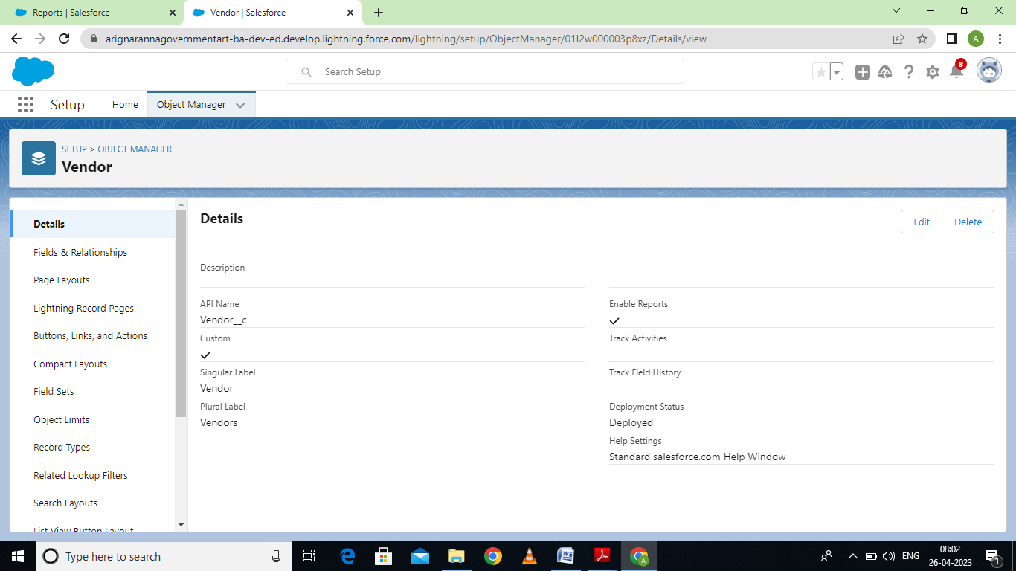

Milestone 3: Tab

Activity 1: Creation event tab:

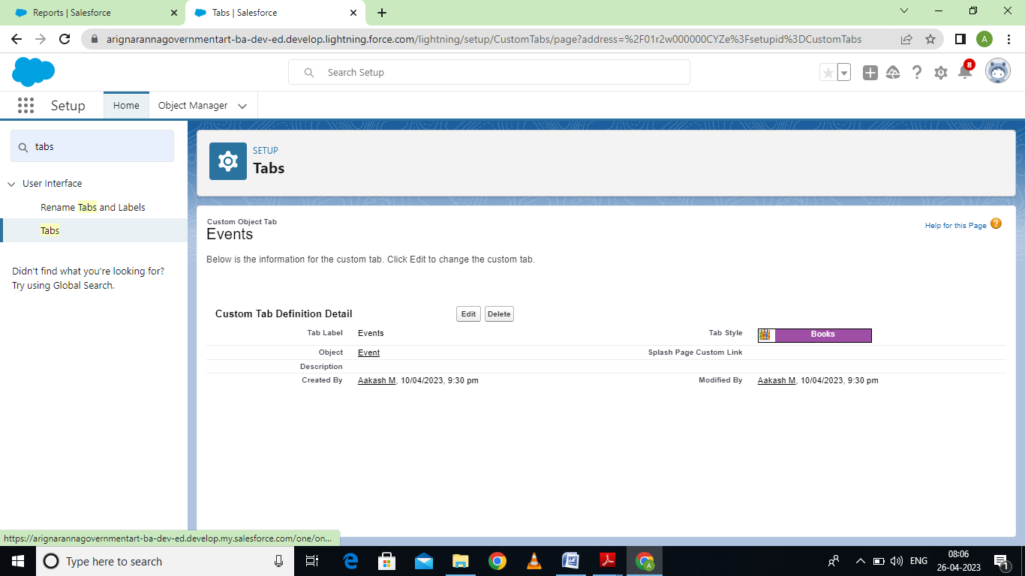

Activity 2:

Creation of Attendee tab:

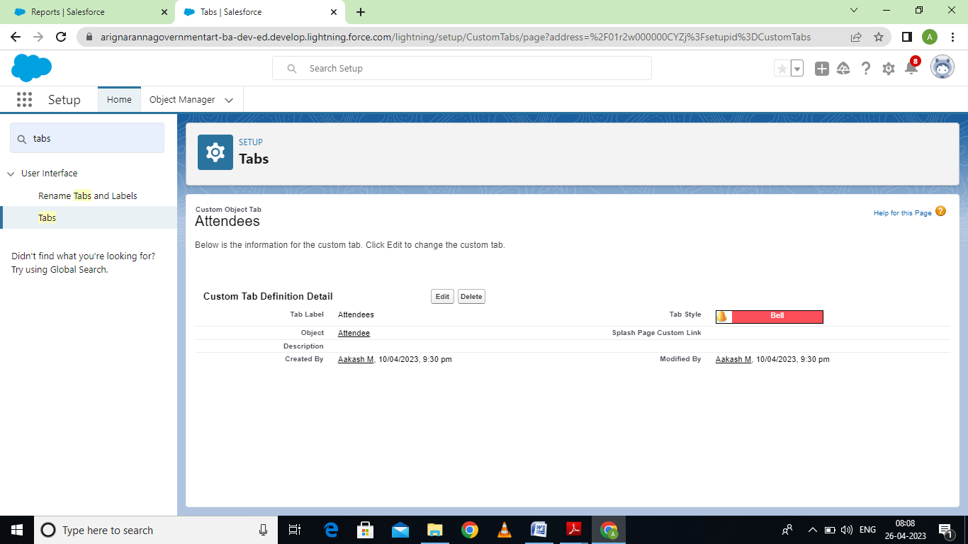

Activity 3:

Creation of speakers:

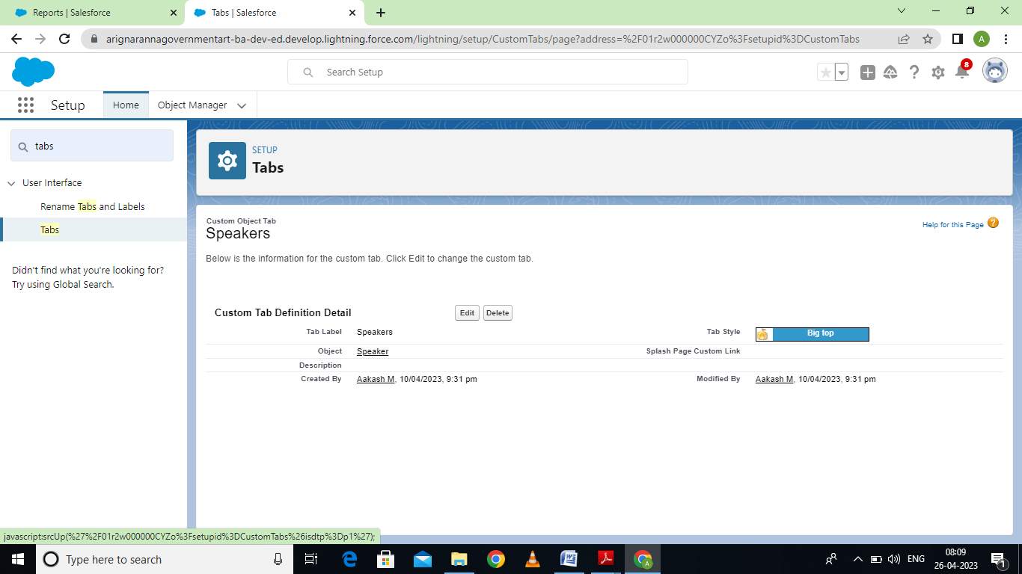

Activity 4:

Creation of vendor tab:

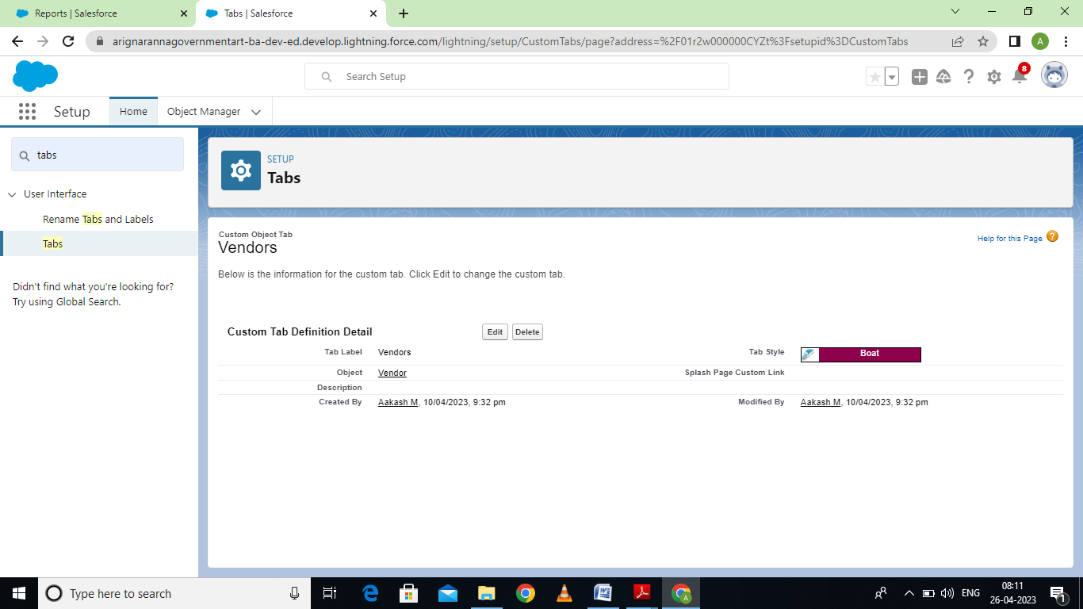

Milestone 3-Application:

Activity: Creation the Event management construction app:

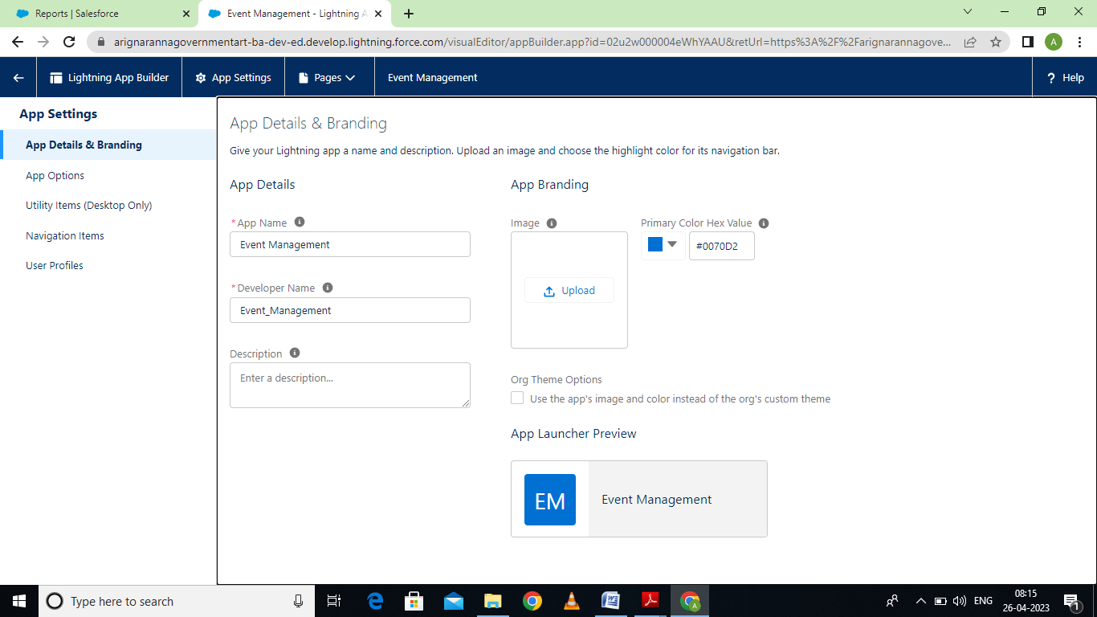

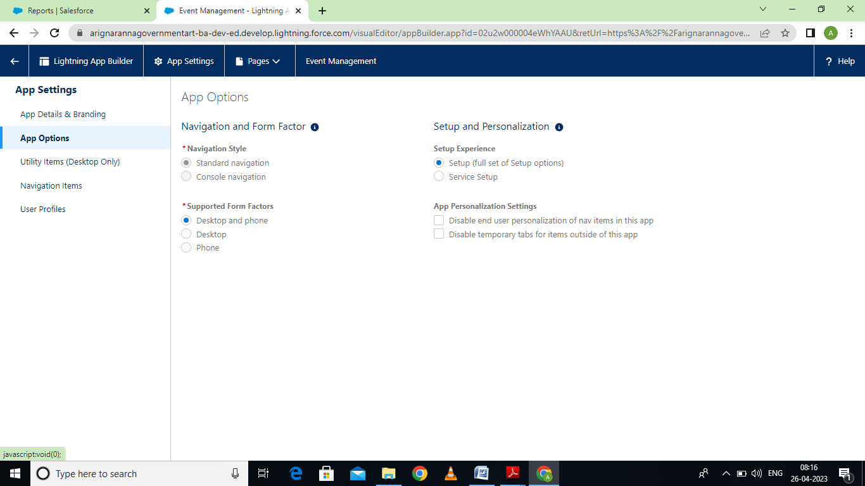

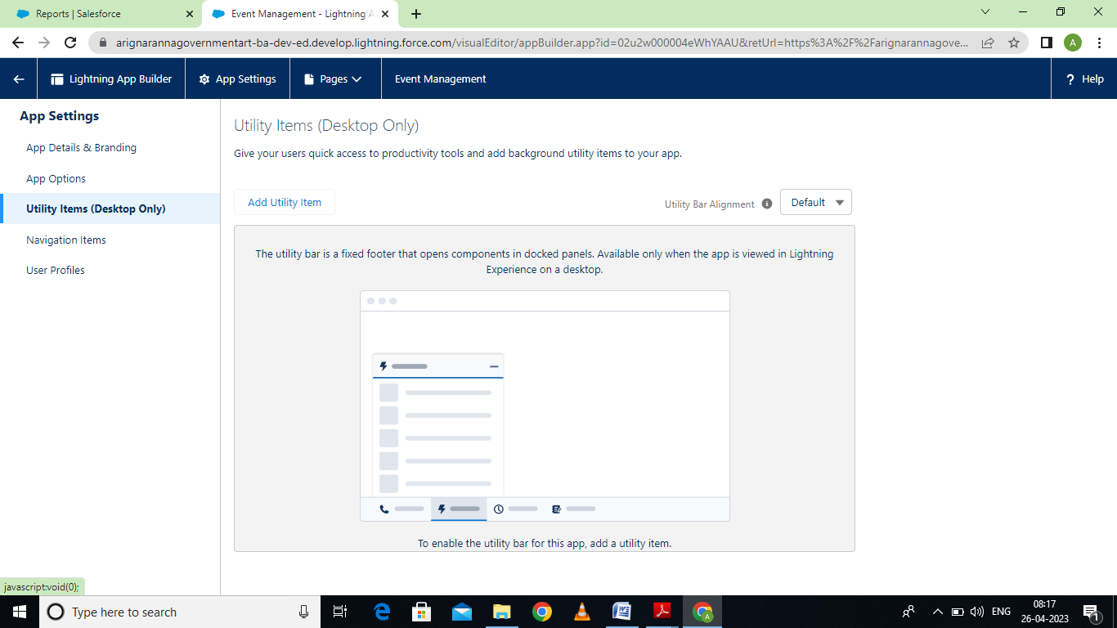

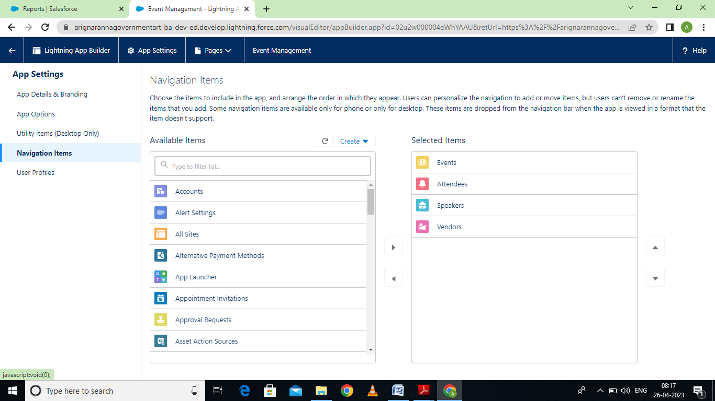

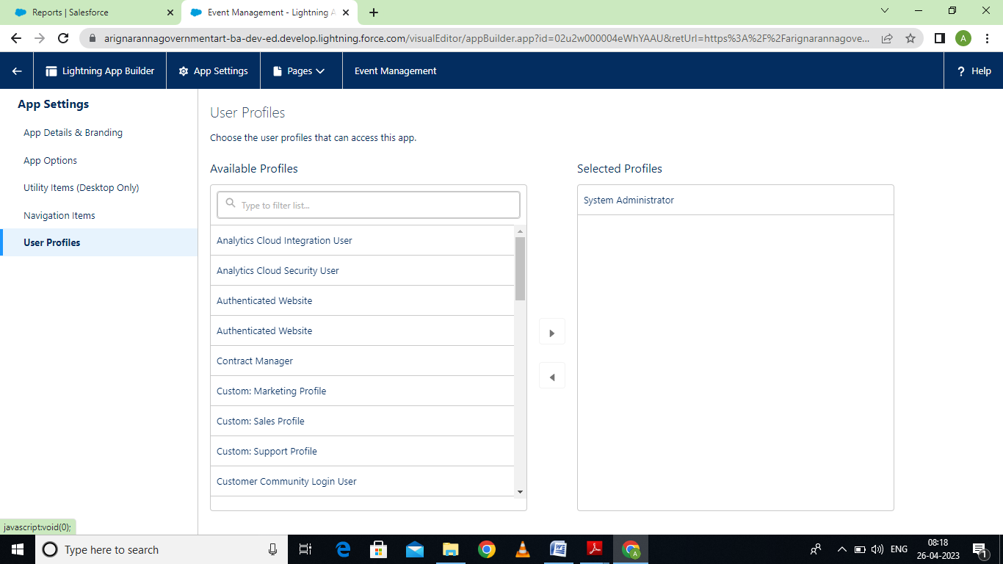

Milestone 4: Fields

Activity 1:

Creation of fields for the Event Objects:

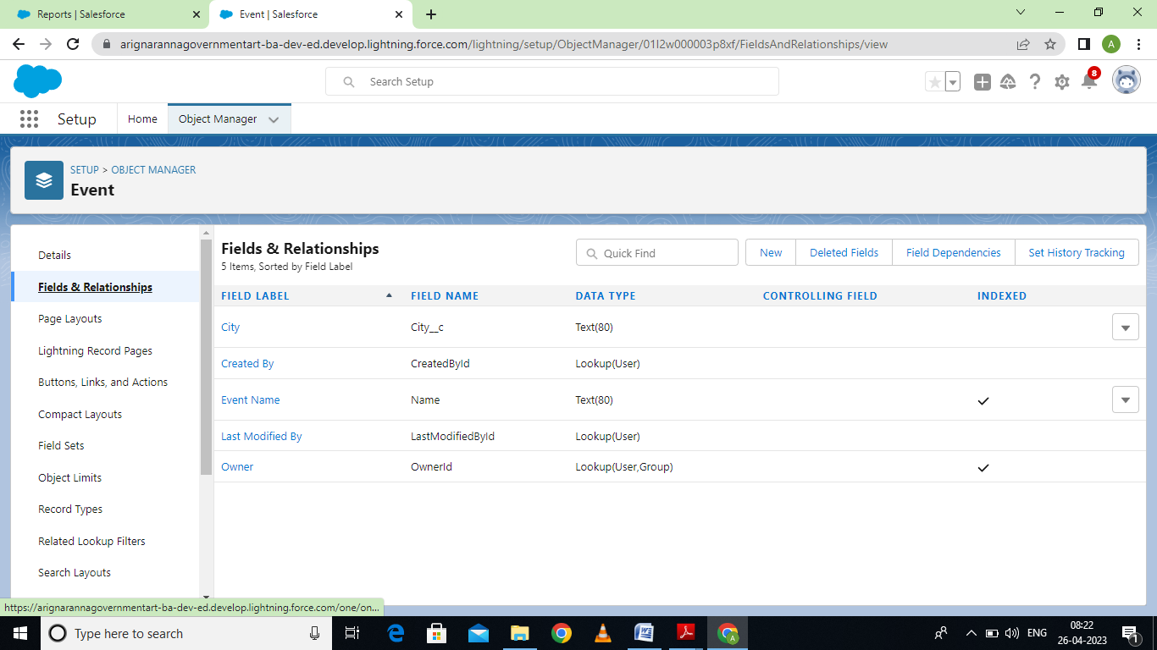

Activity 2: Creation of field for the attendee objects:

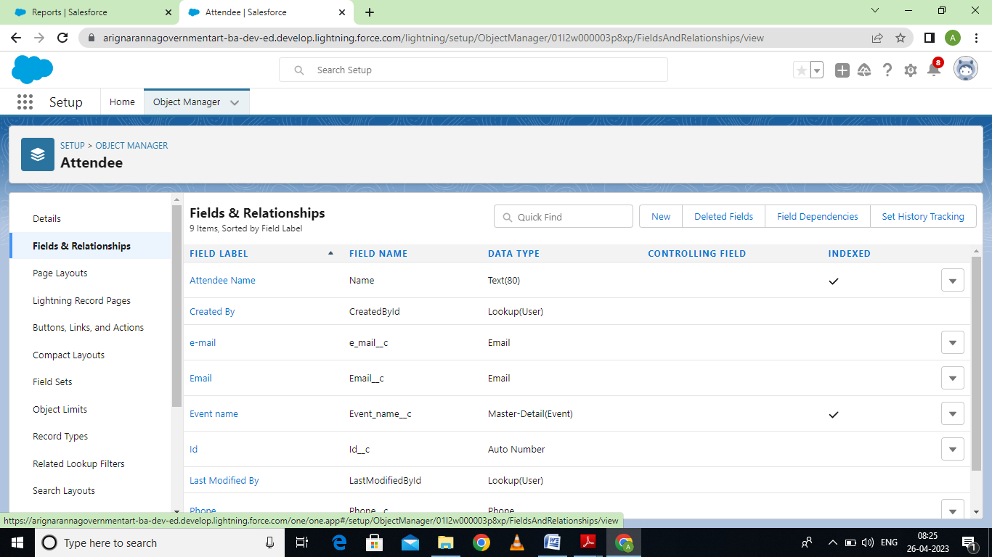

Activity 3: Creation of field for speaker object:

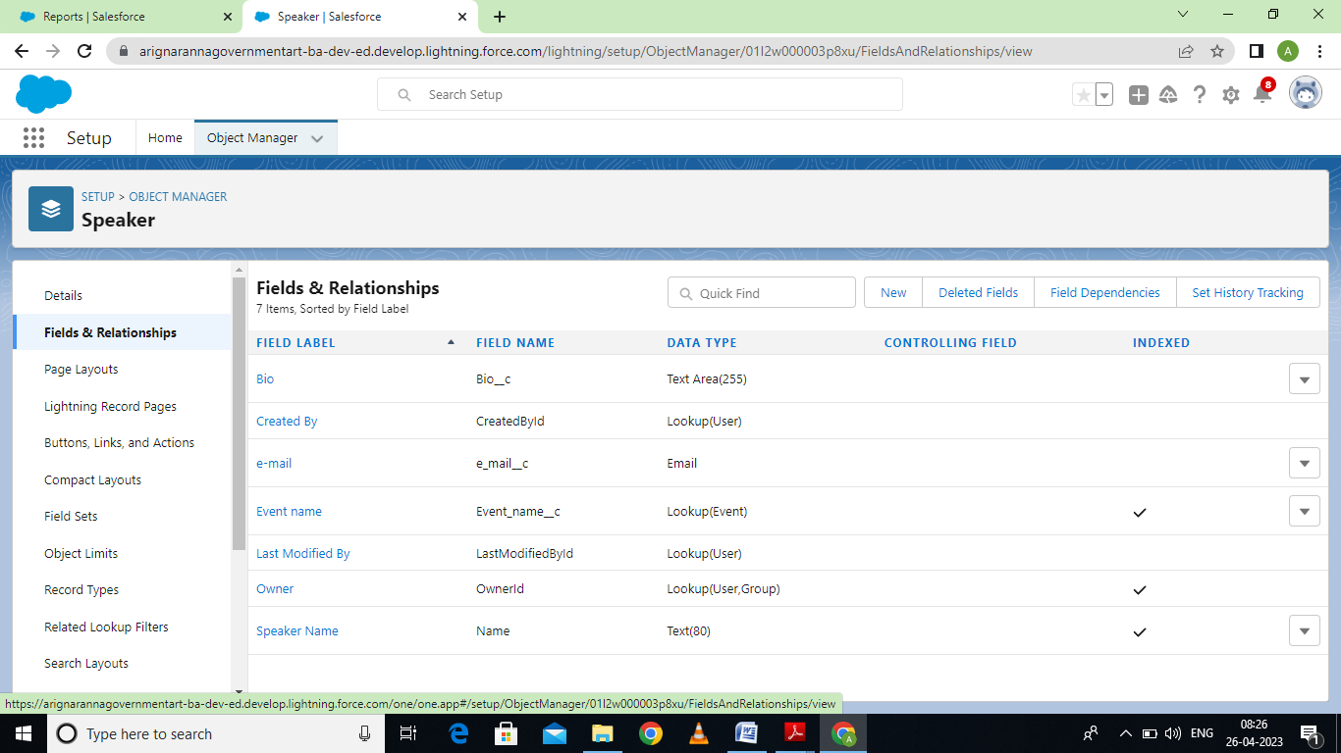

Activity 4:

Creation of field for the vendor objects:

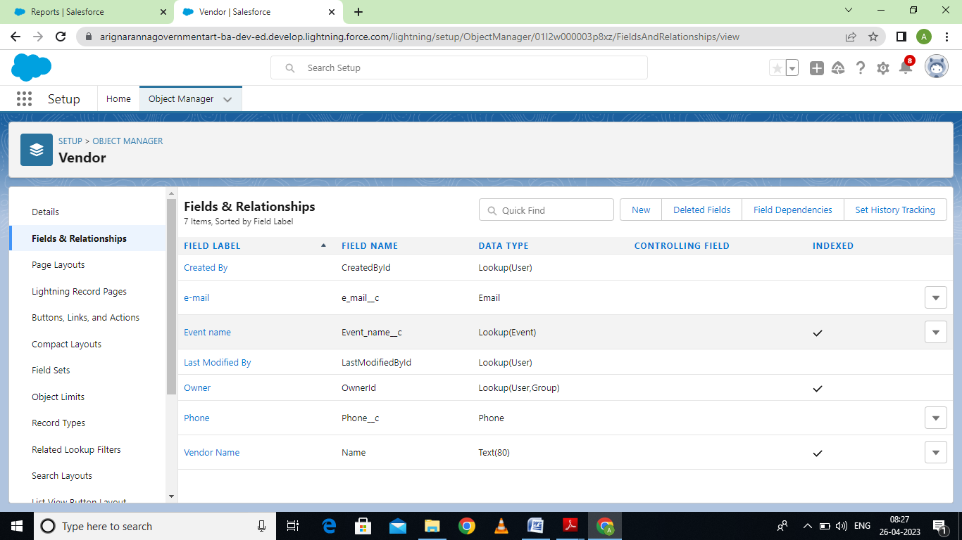

Milestone 5:

Activity 1:Creation of event profile:

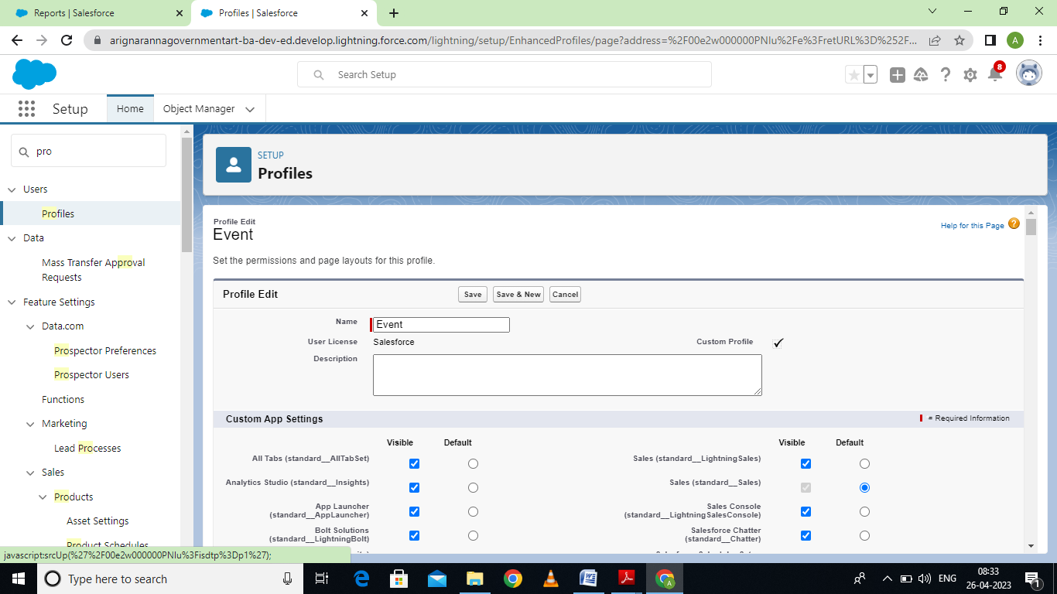

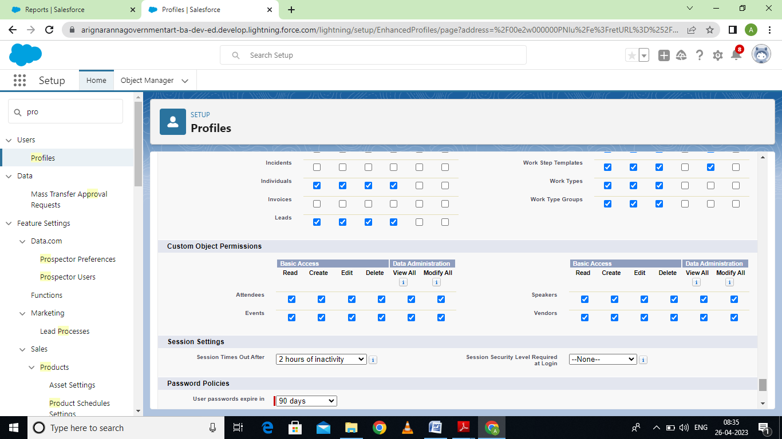

Activity 2: Create a profile name as “ Event vendors profile”

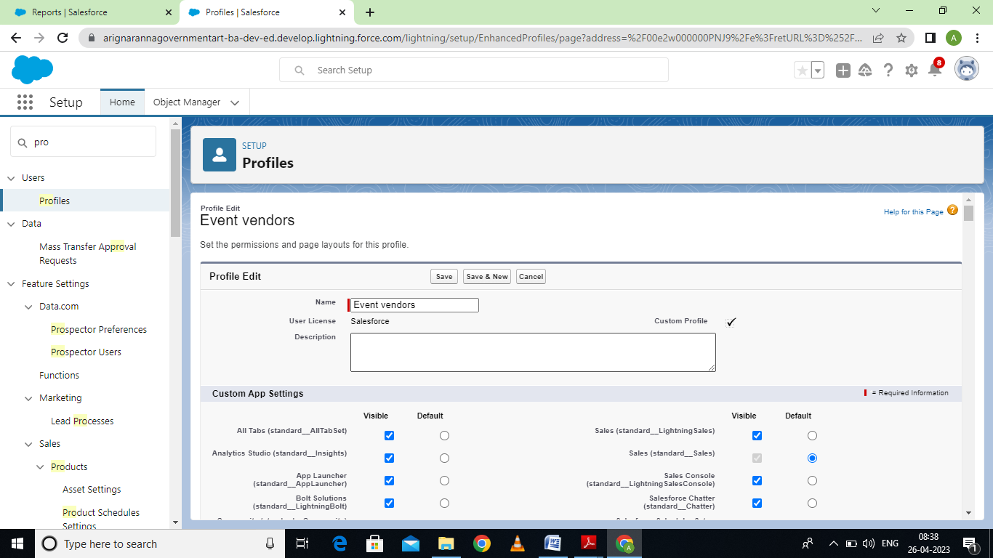

Milestone 6- User:

Activity 1: Creating a user

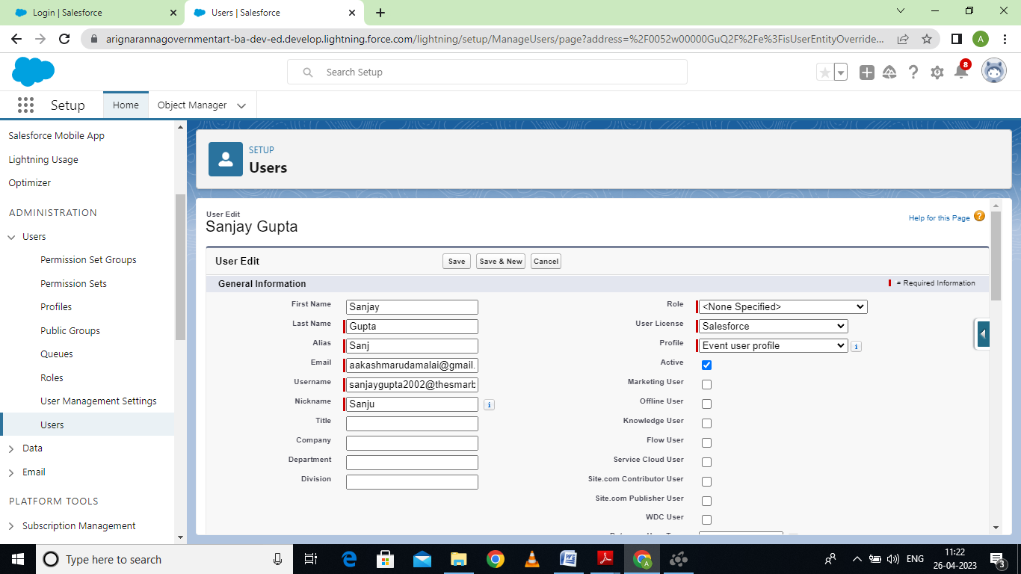

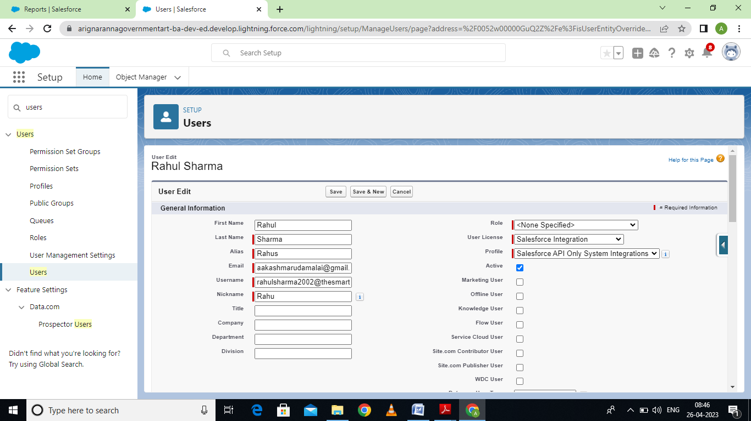

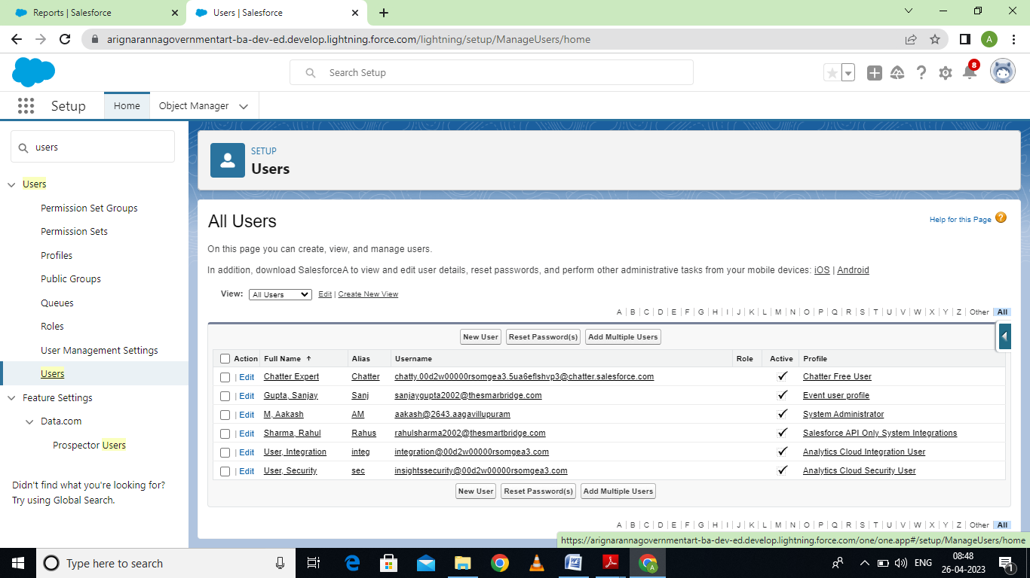

Milestone 7-Permission sets:

Activity 1: Creation a permission set:

Event and permit save:

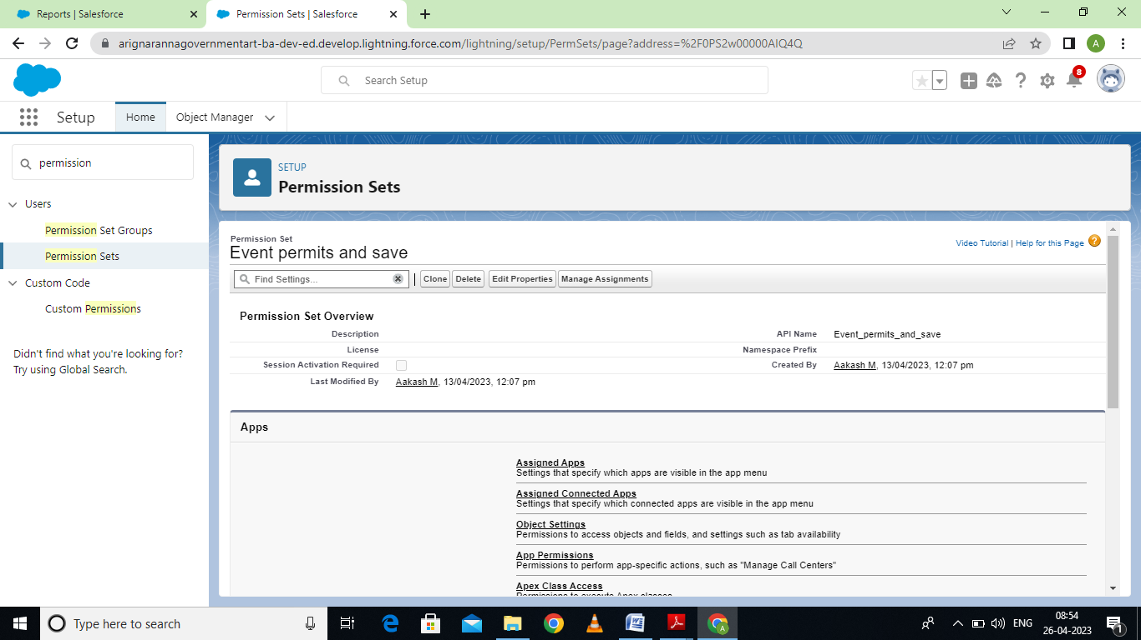

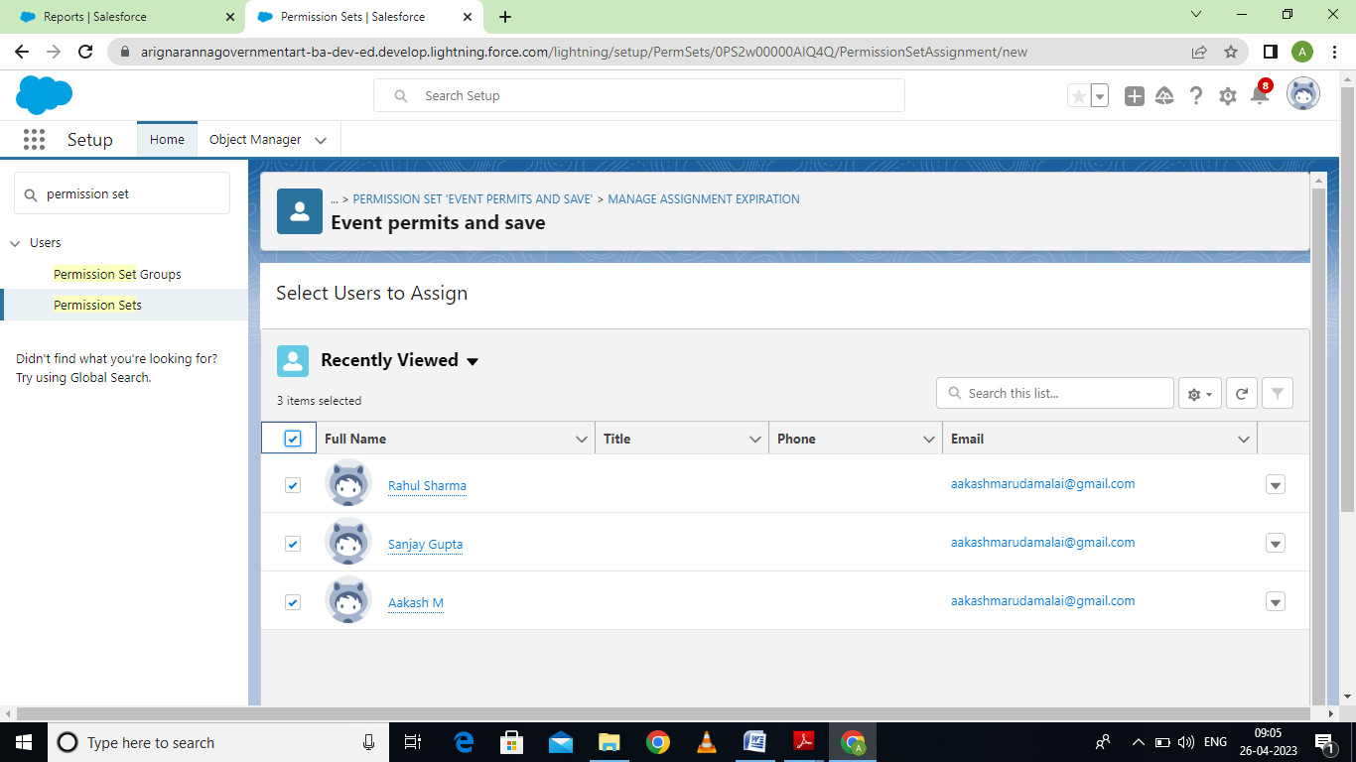

Activity 2: Vendor and permits save:

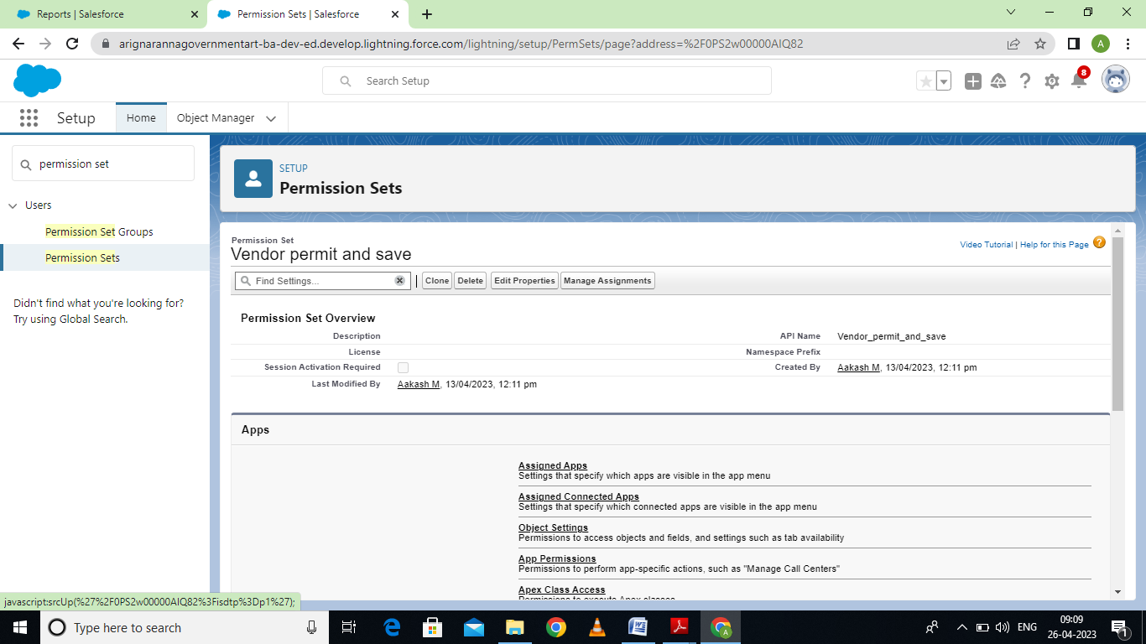

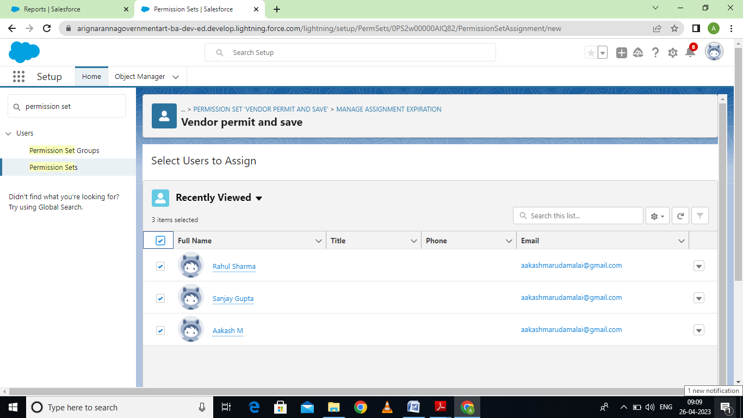

Milestone 8- Reports:

Activity: Creating a report:

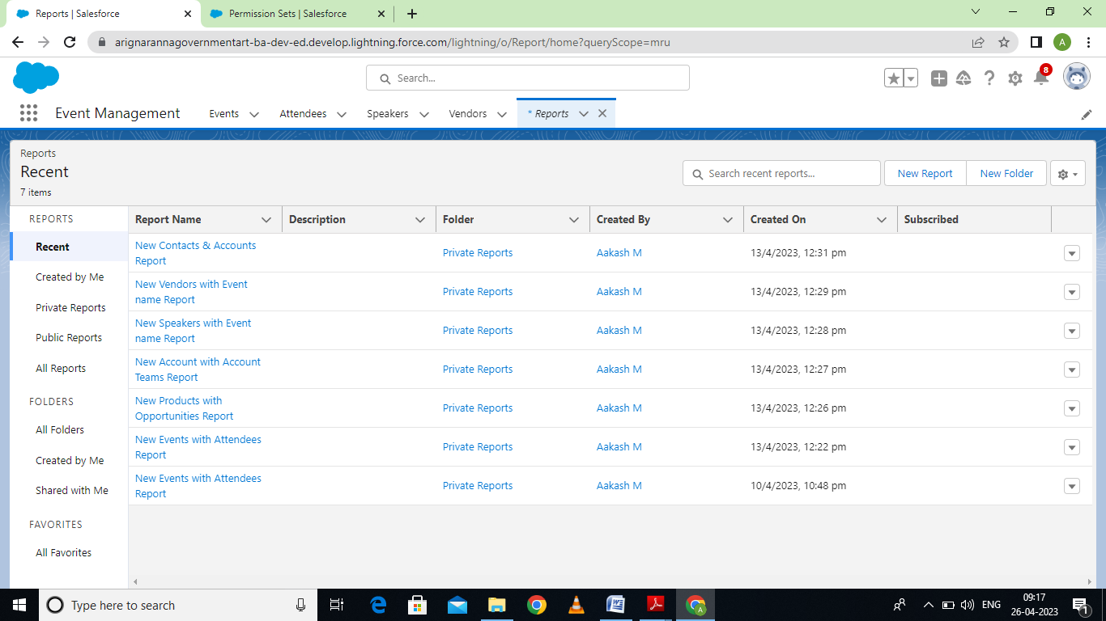

4. Trailhead profile public URL:

Team Lead – <https://trailblazer.me/id/aakasm19>

Team member 1:https://trailblazer.me/id/rrprithibadhanush

Team member 2:https://trailblazer.me/id/rajav58

Team member 3:https://trailblazer.me/id/mshakthi

Team member 4:https://trailblazer.me/id/emalai3

**5. Advantages & Disadvantages:**

Advantages:

* Accelerating the detection and response to incidents.
* Time and money saving automation capabilities.
* More effective decision and action making via automated report distribution.
* Efficiently manage multiple events.
* Use friendly GUI
* Incredibly powerful CRM platform.
* Reduce time for finding location.

**Disadvantages:**

* Expensive
* You have to pay for add on to get the most out of the software.
* Configuration and setup is complex and time consuming.
* Cluttered interface makes navigation and simple tasks unnecessarily complex.
* The learning curve never seems to end.

**6. Application:**

In order to provide the best assistance to campus event planners, a comprehensive event management system must offer:

* Customized processes & scheduling
* Effortless event updates & tracking
* Resources & documentation
* Mobile on the go access
* Hardware & software integration
* Data security & management
* Custom reporting & dashboard

**7. Conclusion:**

In this project, we made attempt to effectively introduce the concept of event management system already existing in the society.

We then explain the concept of online event management system which are already present. We describe the purposed system and explain the features implemented by our proposed system. This project can be further refined and extended by introducing new and more innovative features.

**8. Future scope:**

Whether it’s a big or small events, today people knows the benefit of hiring event management companies. Looking forward to work for more 50 years into this industry sounds interesting. But yes this industry only accepts the hard workers and dedicated ones.

If you have the capacity to work in flexible working hours, to compromise with food and sleep, having patience, communication skill then you can go much ahead into this industry about future is always just a prediction of things that may or may not happen.

Analyzing today’s demand and awareness, it can be said that with more technological world in future and more dynamics in service industries, scope of event managements pretty good.